**Downloading & Installing Terraform**

1. Start by downloading Terraform from [the official download page](https://www.terraform.io/downloads.html).
2. Copy the link address for terraform zip folder and download it using command : wget “link address you have copied”
3. Install the unzip utility if it is not installed in aws instance using apt/yum command.
4. Unzip the downloaded terraform zip file
5. Copy the extracted binary terraform to “/usr/bin” folder.

sudo mv terraform /usr/bin

1. Check the terraform version : terraform -V
2. AWS user creation to create terraform and use the credential for AWS authentication. Go to IAM service in AWS UI.

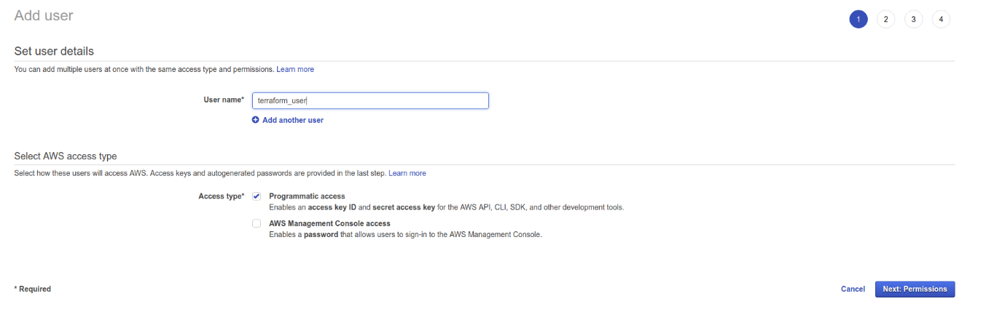

1. Add policy

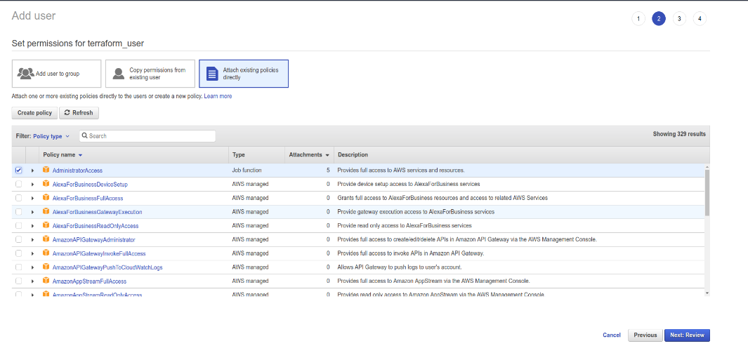

1. Don’t forget to store the AWS access key id and secret access key, download the credentials file:

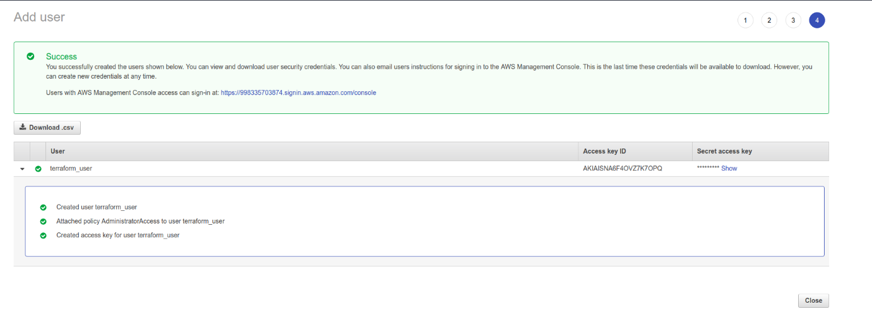

1. Install AWS CLI. Make sure python is installed:

#sudo pip install awscli

#aws configure

1. Check the file cat ~/.aws/credentials
2. Follow the Steps below to provision an instance using Terraform :

#mkdir /home/ec2-user/TerraformProject

#cd /home/ec2-user/TerraformProject

Create the Provider, Resources and Variables file execute the terraform script :

vi variables.tfvars

region = "us-east-2"

shared_credentials_file = "/home/ec2-user/.aws/credentials"

profile = "default"

key_name = "deepaklively2717"

my_ami = {

"us-east-2" = "ami-02f706d959cedf892"

}

vi main.tf

variable "region" {}

variable "shared_credentials_file" {}

variable "profile" {}

variable "key_name" {}

variable "my_ami" {

type = "map"

}

provider "aws" {

region = "${var.region}"

shared_credentials_file = "${var.shared_credentials_file}"

profile = "${var.profile}"

}

resource "aws_instance" "EthansLabs" {

ami = "${lookup(var.my_ami, var.region)}"

key_name = "deepaklively2717"

instance_type = "t2.micro"

tags = {

Name = "EthansLabs"

}

}

**LAB EXECUTION COMMANDS**

1. terraform init # **Get the necessary plugins**

**Make your Dry run for checks :**

1. terraform plan -var-file=variables.tfvars

**Provision your ec2-instances**

1. terraform apply -var-file=variables.tfvars

Destroy the created ec2-instances

1. terraform destroy -var-file=variables.tfvars